Assignment 1
Question:
Create a matrix query to display the job, the salary for that job based on department number, and the total salary for that job, for departments 10, 20, and 30, giving each column an appropriate heading.
Query:
SELECT JOB,
SUM(DECODE(DEPTNO,10,SAL,0)) AS "DEPT10",
SUM(DECODE(DEPTNO,20,SAL,0)) AS "DEPT20",
SUM(DECODE(DEPTNO,30,SAL,0)) AS "DEPT30",
SUM(SAL) AS "TOTAL"
FROM EMP_WIPRO
GROUP BY JOB;
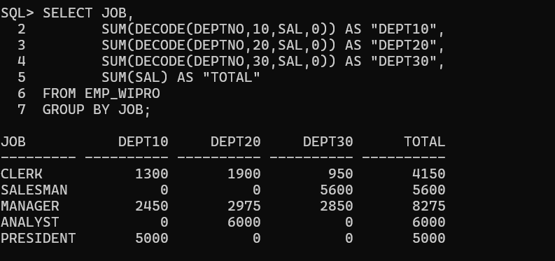
Assignment 2
Question:
Using set operator display the DEPTNO,SUM(SAL) for each department, JOB,SUM(SAL) for each Job and Total Salary.
Query:
SELECT TO_CHAR(DEPTNO) AS CATEGORY,
SUM(SAL) AS TOTAL_SALARY
FROM EMP_WIPRO
GROUP BY DEPTNO

UNION ALL

SELECT JOB,
SUM(SAL)
FROM EMP_WIPRO
GROUP BY JOB

UNION ALL

SELECT 'TOTAL',
SUM(SAL)
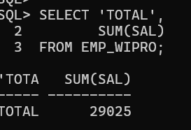

Assignment 3
Question:
Using Set Operator display the JOB and DEPTNO in employees working in deptno 20,10,30 in that order.
Query:
SELECT JOB, DEPTNO
FROM EMP_WIPRO
WHERE DEPTNO = 20

UNION ALL

SELECT JOB, DEPTNO
FROM EMP_WIPRO
WHERE DEPTNO = 10

UNION ALL

SELECT JOB, DEPTNO
FROM EMP_WIPRO
WHERE DEPTNO = 30;
Output:
